8.91: See Problem 8.90. Puck moves at an angle 65.0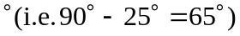 from the original direction of puck A’s motion, and from conservation of momentum in the direction, 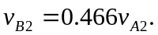 Substituting this into the expression for conservation of momentum in the direction, , and so 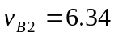 m/s.
As an alternative, a coordinate system may be used with axes along the final directions of motion (from Problem 8.90, these directions are known to be perpendicular). The initial direction of the puck’s motion is 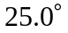from the final direction, so giving the same results.

